Contents

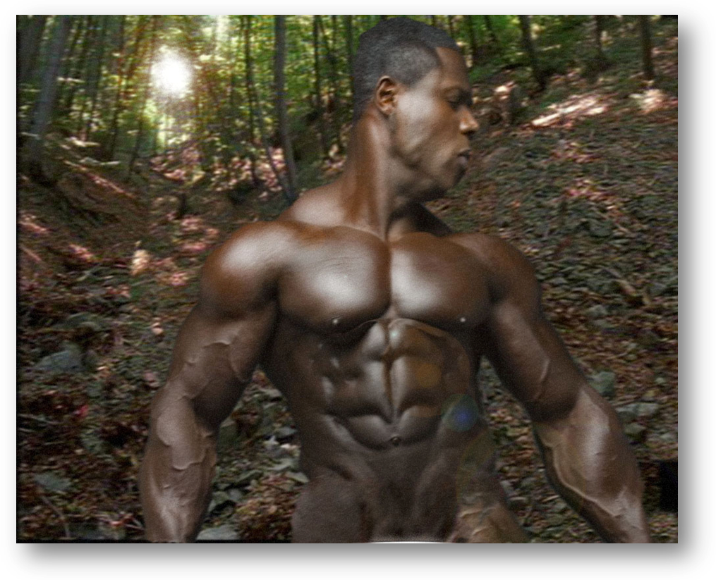
Rescue

1. Lost and found 2
2. Reunion 4
3. The position 5
4. Kiss 6
5. Boys’ toy 7
6. Sell-out 8
End 9

Baited trap
So what happened when the storm stopped and Morgan’s men heard Nakama screaming in the forest?

Lost and found
The first any of them knew about the escape was when they crashed into the clearing to see the black screaming out in agony. Legs thrust out in front, shaking, every thickly powered muscle in his thighs knotted and bulging. Arched back pushing against a tree trunk with such force you’d think he was trying to push it over. Attracted from the screaming in the forest, Morgan’s men saw a muscular frame shaken by a force that far exceeded his own prodigious strength. The savage was in absolute agony. And when the force let him go he collapsed into the mud at the foot of the tree and still he bawled. Head jammed back against the trunk, the mouth torn wide-open by a bawl like a buffalo stuck on a spear. Sobbed, pleaded when he saw his captors arrive.
What the fuck was the black doing here? What the hell was he doing tied to the tree?
No answers but they could see why he was now bawling like a woman in grief. He still had that bracelet on his leg. And no sign of the trigger that was going to turn it off.
“Help me!”
#2 had to laugh. Even when they had been enjoying ploughing his arse, not once had this bastard begged. But they’d heard him scream out something like ten times since his cries had alerted them in the camp. Ten times that bracelet on his ankle had given it to him. And maybe more before they had heard his first scream. Every one of those bastards giving him zaps on full blast.
“Please!”
The cracked voice was frantic. Desperate. His eyes brimming over with his pleas. Knowing that it was only seconds away before the next blast of pain shot his arse up into the air.

“Help me, please. Ya gotta help me!”
As luck would have it, they couldn’t. No sign of the trigger. Any replacement was back at the camp.
He screamed his guts out another time before they got him free of the ropes tying him to the tree. Another dozen times at least they let the bastard collapse writhing to the mud before they got him back to the camp. Trouble was, it was taking him so long to recover from each flash, he’d barely gone a few yards before the zapper blasted into action. Pain exploded all over him and whipped his legs out from under him. Crumpled to the ground. And only 60 seconds before the next blaster was going to cripple him again. Serve the fucker right!
Sympathy? What the fuck! What for? Serve the savage right for making a run for it! What was Morgan going to do when he found out?

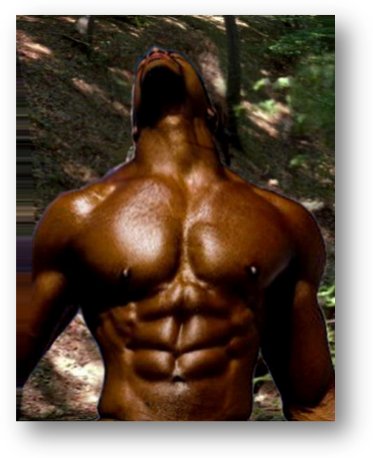
They threw him in an animal cage for safe keeping when they got back. Trouble was, they couldn’t track Morgan down. Couldn’t get their hands on the trigger to switch the bracelet off. By the time they found Morgan unconscious in the shed, the black savage must have taken another twenty. Agony had seized him, he had passed out. But the zaps were still throwing his lifeless torso against the bars of the cage by the time they came with the replacement and switched the bracelet off. A bit anxious, #2 felt for his pulse. The bastard was tough, he had to give him that. He was alive still.
Dumb bastard! He was gonna be exhausted when he came to. He was gonna hurt. But not a touch on how he’d feel when Morgan got his hands on him. Not with apeboy gone too.

Reunited
Nakama had lain in the cage on his side. The sun was high, but he had no idea how long he had been out-of-it. Like some lost undead spirit, he’d lain there, eyes open, couldn’t move. Even when his brain drifted back into working, it had taken some time to piece together how he had finished up in this metal cage so small he could not sit, could only lie on his side with his legs tucked up to his chest. He hurt, he hurt all over. Exhausted in a way he could not remember in his favoured life. His strength had always supported him even when he had challenged himself to the limit. But these agonies he had endured from that thing on his leg were like nothing any human being could manage. He’d come-to. His heart had sank at seeing himself caged like an animal. Back in Morgan’s camp. But then remembering feeling ironically grateful that Morgan’s men had saved him from that eternity of pain that had crippled his unmatchable strength. And then he had collapsed. Unable to sustain another moment of wakefulness. All day, coming-to. And passing out again.
This time, though, something had woken him. A blast of agonising pain. The zapper had set him off again. Slamming him screaming against the bars. By the time his body had some control over itself, he recognised the sight. A pair of legs, hairy, white, untanned. Barely able to work his eyes for his exhaustion, Nakama drifted his eyes upwards over the shorts. To see Morgan staring down at him. At some animal trapped in a cage.
“Not like the company?” Morgan asked. Angry. The ache in his head still hurting from where the apeboy had knocked him out.
“Thought you had better things to do? Someplace else?”
Nakama was exhausted. He lay on his side looking up squinting into the light. Too shattered to take all this in. Yet recognising that thing hung off Morgan’s neck. Back as Morgan’s slave, still prisoner of that trigger Morgan wore. They had rescued him from that Korak’s malicious trick. Leaving him tied to the tree at the mercy of that bracelet. But captive once again, in the hands of the man they had assaulted. The man fingering that thing that set off that pain. Nakama’s blood ran cold.
And that bastard Korak was still free. If Nakama knew anything right now, he’d do something about that. He’d get that apeboy back! He knew where he had gone.
“Get that naked arse of yours outta there. Move, ya black savage!”
The side of the cage was slung open. Nakama forced everything he had into squirming out of the side. Fearing any hesitation would set that thing off again. Rolling quickly over onto the dirt still damp from the recent rains. When he made to stand up, a blow caught him in the backside sending him sprawling head-first into the earth. A blow from the baton Morgan held in his hand.
Seething, Nakama found himself lying there. Realising desperately he had not the strength to do anything about it. Morgan had that trigger around his neck. But still feeling anger rising in his chest at this dishonour. Matched by a nervousness at the weakness of his situation.
“The position”. Morgan’s commanding voice. The words mixed fear and anger in Nakama’s head.
“On your knees. Hands behind the head, ya black fucker!”
Nakama reacted too slow. A thwack across his backbone jarred Nakama into speeding up.
“Behind the head. Now!”
Pain shuddered down Nakama’s torso. His brain ordered his body to do as told.
“Ya learning, ya stinking motha! Takes ya some time. Now up! On ya black fuckin’ knees!”

The position
Even in his exhaustion Nakama seethed. His blood boiled at being commanded like a slave again. So near to freedom yet that had been snatched away. And whose fault was that? Nakama clenched his teeth together like an animal showing his warning fangs. At having to take this all over again. And only one bastard was to blame. He’d managed his escape - and then that Korak had turned, cowardly attacked him from behind. Leaving Nakama for Morgan’s men. But Nakama knew where that ape-brat was headed. With utmost difficulty he struggled up. Anxiously that he was exhausted to the pit of his being, he’d had to use his hands to help himself up. Almost sobbing inside when he became aware how hard it was to get up. A warrior of his envied strength, he couldn’t even manage to get himself up on his knees. For all his muscular power. For all what he looked like. That bastard Korak! His chief’s favourite. His tribe’s best warrior. And Nakama couldn’t struggle to his knees. Because of that brat. The truth of what that bracelet had taken out of him shuddered deep in his guts. How weak he was. How weak that bastard Korak had made him. Nakama ached to make that prick pay for this. He would, he could. He knew just how.
“The position! Ya deaf or what?”
Morgan’s commanding tone had Nakama’s blood boiling. His captive again, after all he had been put through. Anger flared like oil in the fire. But he was in no position to take Morgan on. Even only armed with that stick, there was that thing around his neck. Nakama reluctantly did as told. Frustration burning him up. On his knees, Nakama dragged his hands up behind his head.
On his knees trying not to sway in his exhaustion, straining to keep himself upright, Nakama was conscious of the heavy breathing that rocked his powerful torso. He’d never known such weakness. Fuck that Korak! He’d see him pay for this. Fuck this Morgan too. But he’d use Morgan to get back at Korak. Play the bastards along for now.
“So you don’t take to my hospitality”.
Morgan was prowling. Slowly circling Nakama in glared silence. Eyes boring into him, from the front, from the side. Stopping behind. Nakama stared ahead as expected. Glaringly aware he could not risk angering. He needed to ingratiate himself to get back at that prick who’d landed him in this. He wasn’t up to standing for more punishment. And Nakama was in enough trouble already. He was sure to get it in the neck for Korak’s disappearance. Things did not look good already. No point in earning himself more. He stared straight ahead as expected. On his knees, sensing Morgan lurking behind. Nakama was carefully biding his time, - till he could drop that ape-brat in it.
“Seems you have difficulty hanging on to friends”.
And if Nakama ever got his hands on that Korak again, Nakama would show him just what he thought of him. Silence hung heavy. Morgan behind, saying nothing, doing nothing. But Nakama suspected he was thinking a lot. And his heart sank at the thought that even when they dragged Korak back, he himself still faced a life as a slave. That Korak! So near - yet so far from freedom.
Nakama twitched at the unexpected touch of the baton on his shoulder.
“And you’re gonna tell us where we can find your friend. Gonna help us track him down”.
My pleasure. Just gimme the chance. To face that dickhead when they dragged him back! Suddenly Morgan was coming back round the front. On his knees, hands behind head, Nakama made the mistake of looking at him. For his pains, getting the stick slashed across the face, nearly unbalancing him. Bells rang in his head, tears flashed to his eyes. He thought he tasted blood.
“Eyes front, prick!”

Kiss
“Kiss it!”
Nakama looked at the odious object. He shuddered. Realising the meaning behind the words. Shivering at the offence they implied.
“Now, ya black savage. NOW!”
The blow across the face twisted Nakama’s face and arms over to one side. Head spinning from the baton that smacked burning across his cheek. He took his time in returning back front. Seething at the slap. Hands clasped behind his head busting to lash out. But he’d lose any chance with Morgan then, hope of getting his own back on Korak gone. Burning up with frustration to give back what that slapping deserved, -- even though he didn’t have his former strength. And knowing he’d be taking more, much more. He had to find the strength. That meant playing for recovery time.
His chest rose and fell. As much in anger as in his tiredness. He looked at the offensive object. “Kiss it!” Morgan had snapped. Then getting a grip, rationalising that it was the only way. Play along until he had got back his strength, till he got one over on that Korak. Till he won Morgan over and spilled the beans on the brat. Nakama did as he was told.
Morgan’s foot was stretched out in front. Nakama bent forward on his knees, hands up behind his head, and leaned forward to kiss the boot. As ordered. Ordered to kiss the foot, symbol of acknowledging he was a slave. A slave to this man. Accepting the dominion this man had over him.
But so exhausted, he couldn’t control his move. Toppling forward at the last minute. Just as Morgan whipped away his foot. Nakama landed face-down in the dirt. The boot jarred in his back, pinning his face to the earth. Jerking at the stab of the boot into his backbone. Nearly sobbing to himself at this display of his weakness. Mixed with anger with himself at taking this. Weakened out of all understanding by that thing still on his ankle. Still controlled by that thing - and terrified that Morgan would turn it on again. It wasn’t just that it would weaken him even more. He had to face up to the terrible truth. The thought of more blasts turned him guts to water. He could piss himself at the thought. A warrior of his standing - and he was terrified of a bracelet around his leg.
Nakama jerked at the touch. Something hard on his backside. That stick of Morgan’s tapping at his crack. His face pressed to the earth by Morgan’s boot. His knees trapped underneath. Nakama’s backside was stuck up in the air. And Morgan was tapping away at his arse. .
“I hear ya gave the boys a good time”. Suggestively
With anger Nakama flushed at the recollection. The worst times of his life. That Korak hadn’t had to put up with that, the bastard, only Nakama had. Group rape, over several pride-numbing hours, as “the boys” got nicely drunk and more and more brutal. Animals. Black savage, Morgan called him. Nakama seethed. Morgan should look closer to home.
“Be expecting some reward for bringing you back, they will”, Morgan laughed.
Like hell, they will, Nakama realised. Flushing with anger at the thought and shivering with nerves at what they would do, - both at the same moment.
Morgan’s stick was sliding itself insidiously downward towards that part of him Morgan’s brutes had gone for. Nakama had his teeth bared, pressed into the dirt. Trapped by the boot on his neck and his need to ingratiate himself with Morgan. Angry, frustrated, weak, vulnerable. A shiver at the thought shuddered in his guts. A flush of rage exploded in his head. Fuck ‘em. He was damned if they’d take him without a fight. Every step of the way.

Boys’ toy
Brave words. Fighting Morgan’s men every step. That didn’t allow for how he felt. Shattered.
“’ See the boys couldn’t wait”. Nakama was ashamed at how easily they’d got him roped up under this tree.
Morgan had come back again. And not too soon for Nakama. Could you be pleased at seeing your tormentor come back from taking that radio call? In his absence “the boys” had pounced. He’d fought, he knew what was coming down. And damned if they were going to get away with that. But the first hard jab into his guts shocked him. It wasn’t the lack of definition. He was still the hunk girls couldn’t keep their hands off. It was still a muscled stomach that men wanted to prove themselves against. But one jab into his guts had his eyes popping. His weakened body crumpled shamefully under a hot flush. The crack to his jaw bowled him over in the dust. His body was shattered, it was just not able to take much more. Nakama did his best. He lashed out with his feet, he threw punches back. But they just played with him, laughed at him. Making him only wilder. Yet through all his exertions, in his heart-of-hearts, he knew he’d finish up like this. Meat hung out to dry. He hadn’t got it in him, his fighter-will let down by the weakness of a tortured body.
When they then came at him with a stick and started using it to spread his legs apart, panic sent in. Using his arms tied above his head for support, he kicked out, wildly. He shouted, cursed, warned. The hard punches to his backbone shouldn’t have settled him like that. But for all his desperation, for all his determination, with mocking easiness and some brutal body-blows, they had him standing arms raised under the tree, naked, with his legs splayed wide by a stick. Angry that after all they were going to have their way. And there was damned all Nakama was able to do to stop them.
In no hurry, though. Taunting him was part of the fun. Playing on his nerves, toying with his helplessness got them going. Standing close behind so he could feel them pressing the growing hardness against his bare backside, hands feeling him up inside of his thighs. Creeping up the leg slowly till they were humiliating him by fingering at his balls. Laughing at his threats. Rocking their hard-on’s against him, working themselves up. Sniggering down his ears at his useless threats. A tongue licking up the side of his neck, - like saying, wanna try and stop me? Laughing at him when all their toying with his emotions got him thickening, getting hard himself. Anger, shame and frustration pumping him up. Mocking his inability to stop himself. Laughing at him for getting off on men touching him up.
Missing their chance, though, Nakama was pleased to see. Morgan had come back, business done. The men peeled away mumbling frustrations into the shade. Foiled by the return of their boss in their attempt to take Nakama’s arse. But swearing to themselves they have the fucker yet. Nakama had never been so pleased to see his tormentor. But by now he was seething. For what they’d just done. And done so easily. His hatred was burning away at him inside. At this abuse of his pride. Toying with him as a man. Burning up at his own helplessness. Burning with frustration, needing to lash out and strike them down. Crying out inside at being so weak. But swearing it, he’d get them back. Whatever it took. He’d make these fuckers pay.
“Boys couldn’t wait, it seems”, smirked Morgan.
Morgan’s eyes dropped to Nakama’s naked crutch. Reacting. Half-hard, rising and thickening.
Morgan’s eyebrows twitched. He shook his head, he laughed.
“Neither could you. Ya stinking savage”.

Sell-out
“The ape-boy. What d’ya know?”
Morgan was close. Nakama could smell his foul breath. The baton underpinning the question against his face.
“Where’s he heading?”
Nakama was looking straight into his tormentor’s eyes. Both of them seemed to have forgotten all that talk about slave position and eyes-front.
“Tell me. .. I’ll keep my boys away”, Morgan offered. “They won’t like it. But to get Korak back - worth it”.
Nakama could feel the proximity of the man. He could feel the heat between their chests. Morgan was that close. That close and yet so far. Nakama wanted like nothing else in life than to have one of his hands free. Just to lash out. Just to let out all that pent-up anger that trembled through his whole being. Scorn for this man. Hatred for his “boys”. Fury for daring to mock his manliness. Raging anger that he was back in their hands and condemned to a lifetime of this kind of slavery.
“You want my boys beat it outta ya?”
Morgan was tapping that baton against Nakama’s cheek.
“Ya know they want to. Ya know they’ll enjoy it”.
Nakama had no doubt. They’d beat him to pulp. But would he give? Would the burning rage that gripped him give way to the fury of their fists and tell them what they wanted to know? Where Korak was headed.
He saw a plan forming, he’d realised he had one strength left. One way of fighting back. They wanted something from him, - where Korak had gone. That was his one way of giving vent to all this raging emotion. To deny them that. To really piss them off. Keep secret what they wanted to know above everything else.
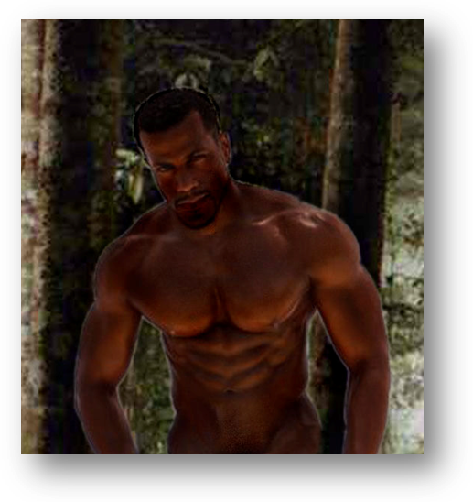
Playing the part, he cast his eyes over Morgan’s head. Look eyes front, playing the submissive slave.
“My tribe. They’ve got Tarzan. He’s going back for his father. Rescuing the old man”.
The temptation to snatch Tarzan when they raided the tribe would be too much for Morgan to resist, Nakama knew that. But Nakama would have to lead them, show them the way. With luck, straight into a trap. It would be a battle. Blood would be spilled. But Nakama knew Morgan’s set-up. There would be only half dozen of them. Going up against a tribe of warriors fighting for their lives. No contest. Nakama would be free. And then Morgan would see what they were dealing with.
Morgan smiled. It was as easy as that. The black savage had spilled the beans. For all that bluster and muscle, the prick could not take any more. That bracelet had done him in. He looked good, a stud like him was worth a mint. But muscle against electronics - no contest. The sucker had given Korak up.
Morgan would set off at first light. And with any luck, they’d come back with Tarzan as well.
Morgan nodded back at the slave. Hands caught overhead. Legs splayed by the spreader. Bare-arsed like the day he was born. He nodded appreciatively. Showing gratitude for the information.
Then Morgan looked over his shoulder. Caught the eye of #2.
“He’s ratted on his mate. Sold us the ape-boy back”.
Turning back to Nakama. The softness in Morgan’s eyes letting him know how he was appreciative he was.
“He’s yours, boys”. The contented smile creased Morgan’s face. Continuing to talk to #2.
“Give it the fucker. Good-and-hard”.

End

